Success in the DataCenter-Insider readers’ poll
Corporate Communications
Dr Carola Hilbrand
Phone: +49 2772 505- 2527
E-mail: hilbrand.c@rittal.de
Hans-Robert Koch
Phone: +49 2772 505- 2693
E-mail: koch.hr@rittal.de
Steffen Maltzan
Phone: +49 2772 505- 2680
E-mail: maltzan.s@rittal.de
Rittal GmbH & Co. KG
Auf dem Stützelberg
35745 Herborn, Germany
www.rittal.com

Best cooling provider: Rittal wins at the “IT Awards 2022”
Between April and August, no less than 72,000 readers voted to choose the best IT companies of 2022. The winners of Vogel Business Media’s “IT Awards 2022” have now been made public. At a celebratory awards ceremony in Augsburg on 20 October, Rittal won the platinum award in the “Cool Cooling” category, honouring the company as the best provider of IT cooling solutions. The seven major specialist portals for IT professionals were: data centre insiders, big data insiders, as well as insiders in cloud computing, development, IP, security and storage.
Herborn, 27 Oktober 2022 – The decisive factor in the editorial team’s pre-selection was that between 2021 and 2022, IT companies had distinguished themselves, for example, through inventive talent, pioneering strategies or market intuition. Consequently, readers of the seven Vogel Business Media insider portals could vote for their favourites and even submit their suggestions. As a result, the 2022 IT Awards were presented in a total of seven categories: “Cool Cooling,” “Data Centre Automation,” “HPC and AI Hardware,” “Intelligent Facility Components,” “Multi-cloud Platforms,” and “Sustainable Colocation.”
Rittal received the platinum award as the best company providing IT cooling solutions in the first category, “Cool Cooling,” ahead of Stulz (gold) and Thomas-Krenn.AG (silver). “We are delighted at winning this prestigious award, which once more confirms our expertise in developing IT cooling solutions and their high level of acceptance on the market,” said Michael Nicolai, IT Sales Manager Germany at Rittal.
Rittal develops needs-based and innovative IT cooling solutions ranging from individual racks to the climate control of suites and rooms, and through to customised climate control systems for sophisticated high-performance computing (HPC). With its IT cooling product range, the system provider also meets the requirements of intelligent and energy-efficient cooling.
Cooling in a container
The latest examples are Rittal data centre containers with Blue e+ cooling technology. With the aid of a new outdoor cooling solution on the outside of the container, based on the industry-proven Blue e+ technology, more space is created within the modular data centre container for the constantly growing information technology. This also provides the added potential for flexibly expanding the applications. At the same time, energy consumption is reduced by a third. This makes it easier for data centre container operators to save on operating and energy costs. Furthermore, it is no longer necessary to install the previously needed raised floor and the corresponding cooling technology inside the container – nor the otherwise usual refrigerant piping between the inner and outer circuits. The cooling unit can thus be directly attached to the container’s wall cut-out. This not only saves space but also assembly work while saving assembly time and money.
(3,037 characters)
■

Caption(s)
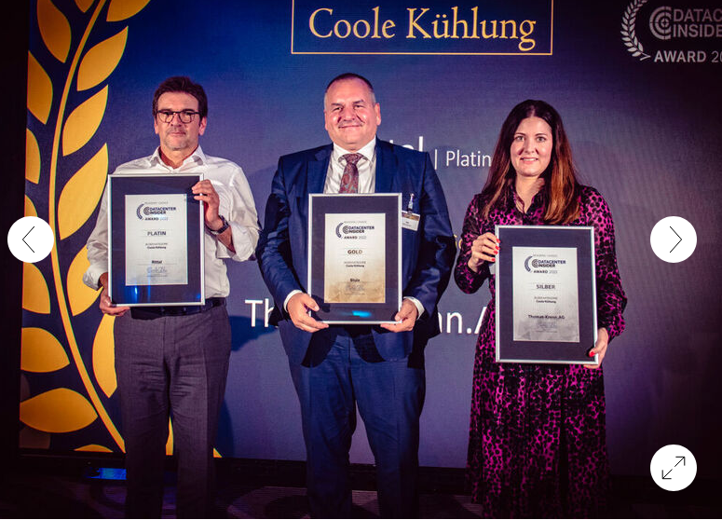
Image 1: Rittal received the platinum award as the best company providing IT cooling solutions in the category, “Cool Cooling,” ahead of Stulz (gold) and Thomas-Krenn.AG (silver). From left to right: Michael Nicolai for Rittal (platinum), Mirko Hoffmann von Stulz (gold) and Julia Mitterdorfer for Thomas-Krenn.AG (silver). Image: krassevideos.de / Vogel IT-Medien GmbH)
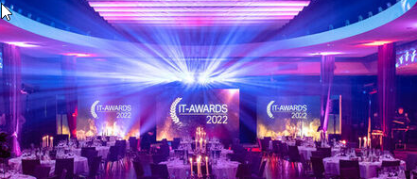
Image 2: The award ceremony was held on 20 October in Augsburg’s “Maximilian’s” hotel. Image: krassevideos.de / Vogel IT-Medien GmbH)
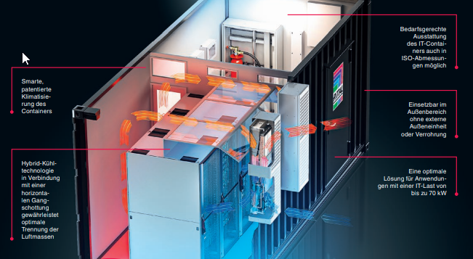
Image 3: In data centres, every square metre of space and every kilowatt hour of electricity counts. What’s needed are all-in-one solutions that free up space while also significantly cutting power consumption. Providing proof that both these needs can be met is a new Rittal cooling solution for IT containers.

About Rittal
Rittal, headquartered in Herborn, Germany, is a leading global provider of solutions for industrial enclosures, power distribution, climate control and IT infrastructure, as well as software and services. Systems made by Rittal are deployed in over 90 per cent of all industries across the world, including machine building and plant engineering, food and beverage, and IT and telecommunications.
The international market leader’s product portfolio includes configurable enclosures, with data available across the entire production process. Smart Rittal cooling systems, with up to 75 per cent lower power and a great carbon emissions advantage can communicate with the production landscape, enabling predictive maintenance and servicing. The offering also includes innovative IT products, from IT racks and modular data centres, to edge and hyperscale computing solutions.
Leading software providers Eplan and Cideon support the value chain, providing interdisciplinary engineering solutions, while Rittal Automation Systems offers solutions for switchgear. Within Germany, Rittal can supply products on demand within 24 hours – with precision, flexibility and efficiency.
Founded in 1961, Rittal is the largest company in the owner-operated Friedhelm Loh Group. The Friedhelm Loh Group is active worldwide, with 12 production sites and 90 international subsidiaries. It has more than 11,600 employees and posted revenues of € 2.6 billion in fiscal 2021. In 2022, the family-run business was named one of Germany’s leading employers by the Top Employers Institute, for the 14th year running. Within the scope of a Germany-wide survey, Focus Money magazine identified the Friedhelm Loh Group as one of the nation's best providers of vocational training for the fifth time in 2021. In 2022, Rittal was awarded the Top 100 Seal as one of Germany’s most innovative medium-sized companies.
For more information, visit www.rittal.com and www.friedhelm-loh-group.com.

